** HIGH PRESSURE INJECTION MACHINE**

**Powerful, extremely lightweight injection pump for the complete line of injection grouts.**

**ADVANTAGES**

Plastic Container

* Heavy duty for daily use
* 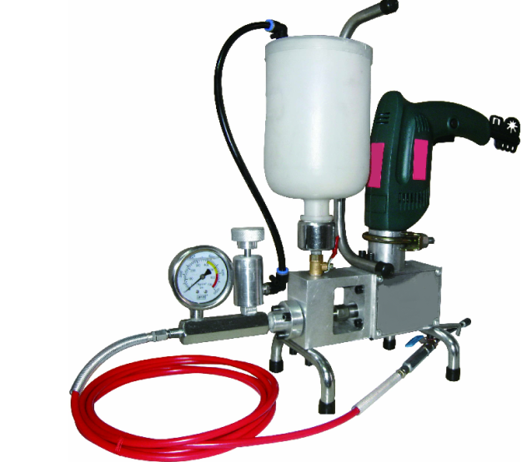Lightweight
* 8,000 psi

Impact Drill

* Easy to use, clean & maintain
* Single component

Pressure Gauge

* Pressure gauge
* Hopper included
* Recommended for beginners and injection pros

Main Body

* Compatible with PU and Epoxy

Cylinder

**USES**

Nozzle Set

All kinds of cracks and joints in concrete, such as:

* Cold joints
* Expansion joints
* Working cracks​

Injection Valve

Piston

High Pressure Hose

**PHYSICAL DATA**

|  |  |
| --- | --- |
| INJECTION PUMP | |
| Max Pressure | 12,000 psi |
| Max Hose Pressure | 22,500 psi |
| Max Air Valve Pressure | 18,000 psi |
| Voltage | 110 V |
| Weight | 5 kg |
| Injection packer sizes: | Ø 10 mm x 100 mm |

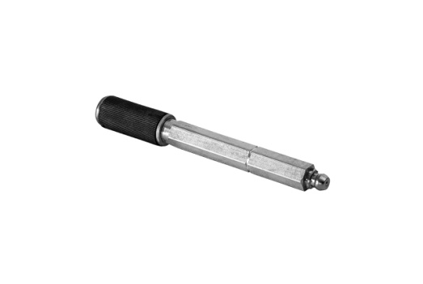

Injection Packer

**APPLICATION**

Step 1: Clean Surfaces

Step 2: Drill Injection Holes

Step 3: Insert Injection Packers

Step 4: Flush Crack If Necessary

Step 5: Crack Injection

Step 6: Clean Up​

**SAFETY**

Impervious gloves and barrier cream should be used when handling these products.

Eye protection should be worn. In case of contact with eyes, wash thoroughly with plenty of water and seek medical advice if symptoms persist.

If contact with skin occurs, it must be removed before curing takes place.

Wash off with an industrial skin clearer followed by plenty of soap and water. Do not use solvent.

Ensure adequate ventilation when using these products.